5. “Factor Momentum and the Momentum Factor” Paper replication

Group Member: Lin Jianan

Table of Contents

5. “Factor Momentum and the Momentum Factor” Paper replication 1

1 Introduction 3

2 Data Source and Preprocessing 3

3 Method 3

4 Assumptions 4

5 Backtest result 4

5.1 No transaction cost 4

5.1.1 Mainland China 4

5.1.2 Hong Kong 8

5.1.3 US 12

5.2 Transaction Cost = deduct total return by 50% monthly. 16

5.2.1 Mainland China 16

5.2.2 Hong Kong 19

5.2.3 US 22

5.3 Extra mile: Introduce 1-month moving average of factors returns, assume no transaction cost. 25

5.3.1 Mainland China 25

5.3.2 Hong Kong 28

5.3.3 US 31

6 Conclusion 34

6.1 Comparison with findings in original paper. 34

6.2 Comment on Sharpe Ratio of the strategy from extra mile. 35

6.3 Comment on profitability of such strategy 35

6.4 Effect of transaction cost to the trading strategy 36

7 Reference 36

# Introduction

In this report, we replicated momentum trading strategy based on principal component analysis (PCA) propose by Ehsani & Linnainmaa, 2022. Although result of this replication agrees with findings from original paper. Nevertheless, such trading strategy is not robust enough to profit in terms of time and geographical areas.

# Data Source and Preprocessing

We use monthly data from Rayliant about 100 risk factors in mainland China, Hong Kong and US markets from Aug 2000 to Dec 2021.

During data preprocessing, we filtered away factors related to momentum so that we will not study momentum of momentum, which is not the focus of paper to be replicated. Also, we only keep factors that always have data throughout backtesting period. This helps monitor effectiveness of replicated trading strategy on the same factors. Finally, in order to have comparable back test result, old data were removed to make back test period for the 3 markets to be the same.

# Method

The idea of trading strategy to be replicated is to long factors weighted by eigenvectors with high eigenvalues in PCA using previous 1-year returns. Then, we short factors weighted by eigenvectors with low eigenvalues in PCA.

The detailed process of each iteration is:

1. Compute eigenvectors from the correlation matrix of daily factor returns starting from 1 Jan 1973 to month t.
2. Compute monthly returns of portfolios in which factors are weighted by each principal component. Each portfolio is a PC factor. We get time series of monthly return of each PC factor from 1 Jan 1973 to month t.
3. Rescale all PC factors so that their average returns from 1 Jan 1973 to month t are zero and their time series variances match that of the average original factor up to month t;
4. Long PC factors with positive average returns from month t − 11 to t and short PC factors with negative average returns from month t − 11 to t.
5. Compute the return on the resulting strategy in month t + 1. This is backtest result of this iteration.

The above iteration continues until the latest data is fed into backtest system.

# Assumptions

Assume that we invest globally, so interest rate of US treasury is treated as risk-free rate in Sharpe Ratio calculation since US treasury bills is supposed to be the most safe asset class.

Assume we invest in fixed amount monthly because the downside potential and volatility of such trading strategy is very large. Once the loss exceeds 100%, it is impossible to reinvest.

# Backtest result

Notes:

* The graphs and tables can be found attached jupyter notebook file by searching “Replicate table X”, where X is 1, 2 or 3.
* Every graph and table shown in the jupyter notebook has title referring to tables replicated from original paper.

## No transaction cost

### Mainland China

#### Table 1

Equally-weighted portfolios

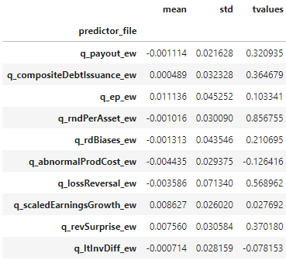

Value-weighted portfolios

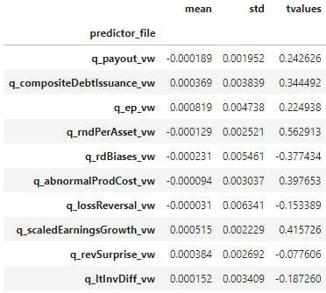

#### Table 2

Equally-weighted portfolios

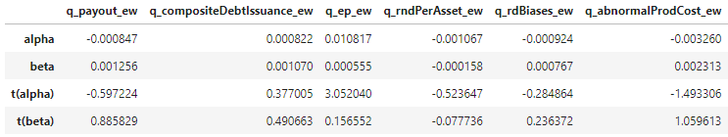

Value-weighted portfolios

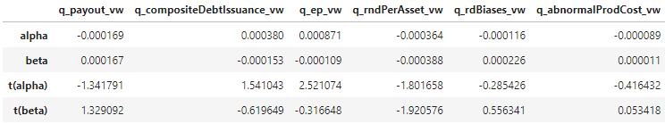

#### Table 3

Panel A, equally-weighted portfolios.

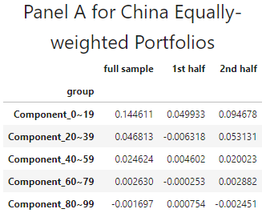

Panel A, value-weighted portfolios

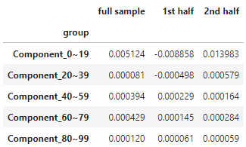

Panel B, equally-weighted portfolios.

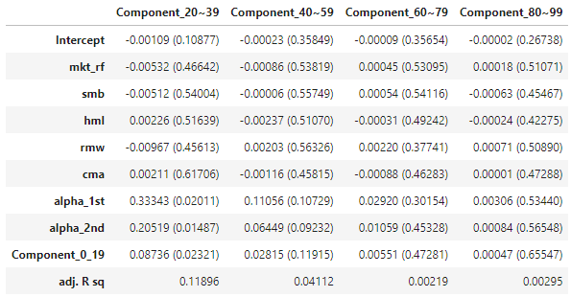

Panel B, value-weighted portfolios.

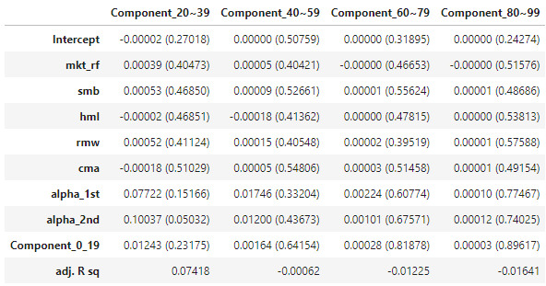

Panel C, equally-weighted portfolios

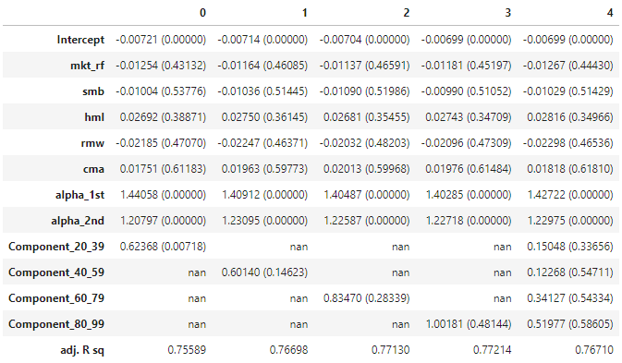

Panel C, value-weighted portfolios.

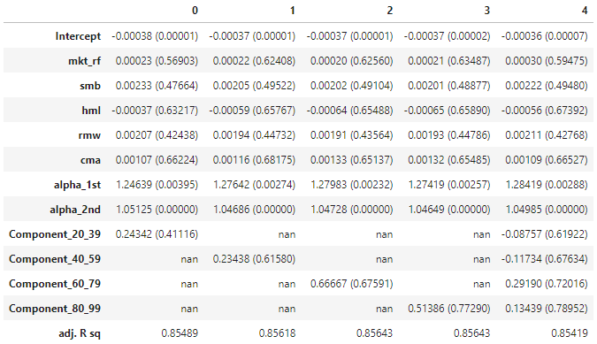

#### Sharpe Ratio

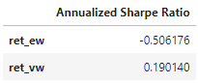

#### P&L Curve

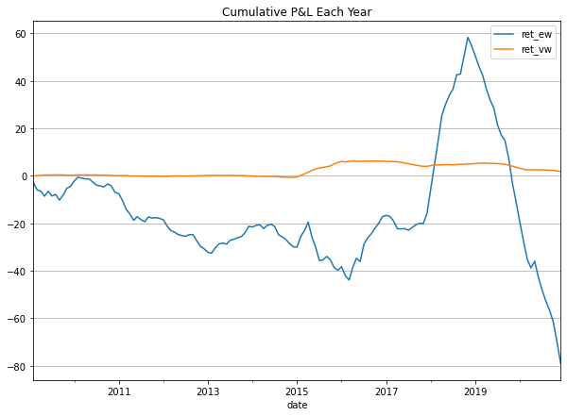

### Hong Kong

#### Table 1

Equally-weighted portfolios

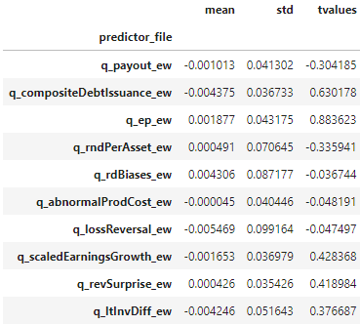

Value-weighted portfolios

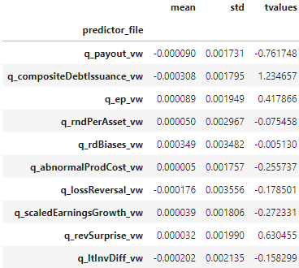

#### Table 2

Equally-weighted portfolios

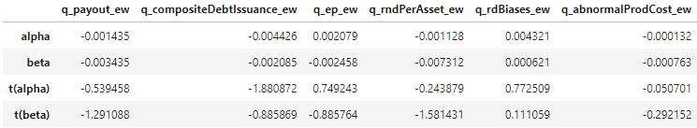

Value-weighted portfolios

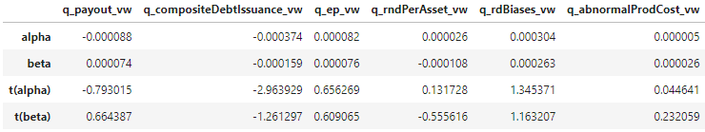

#### Table 3

Panel A, equally-weighted portfolios.

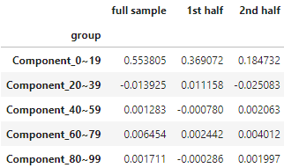

Panel A, value-weighted portfolios

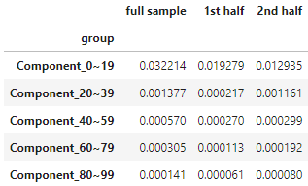

Panel B, equally-weighted portfolios.

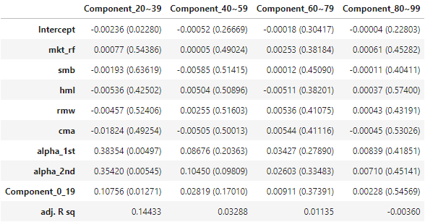

Panel B, value-weighted portfolios.

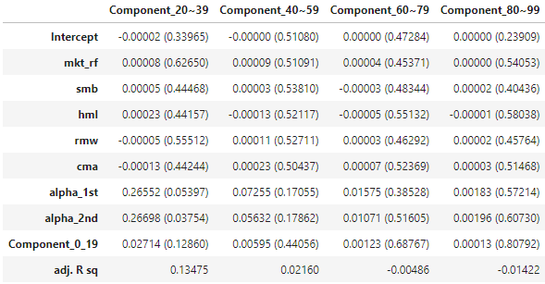

Panel C, equally-weighted portfolios

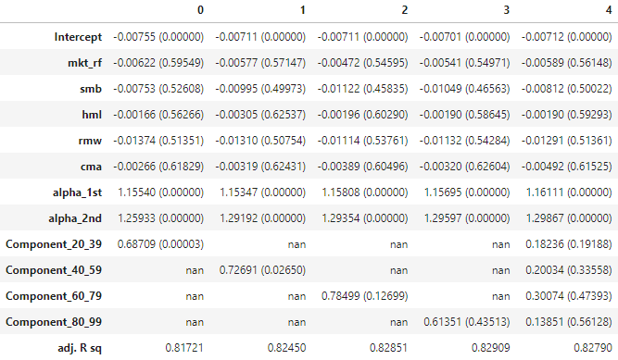

Panel C, value-weighted portfolios.

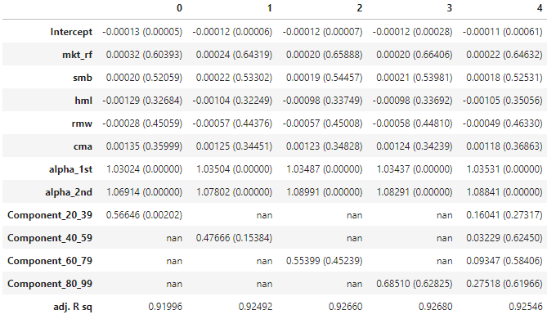

#### Sharpe Ratio

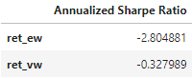

#### P&L Curve

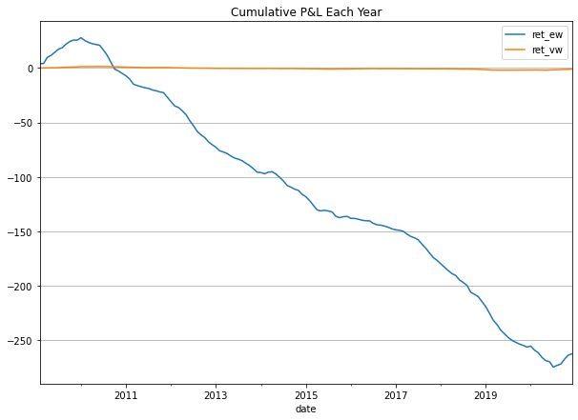

### US

#### Table 1

Equally-weighted portfolios

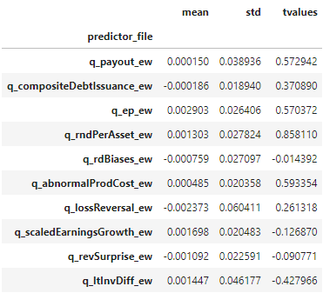

Value-weighted portfolios

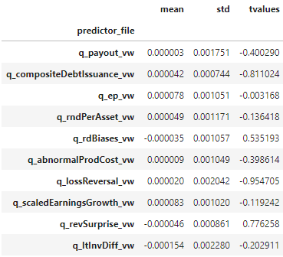

#### Table 2

Equally-weighted portfolios

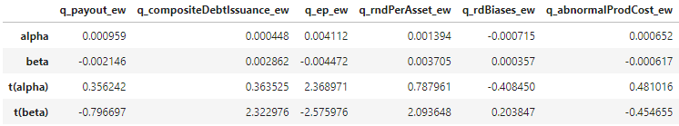

Value-weighted portfolios

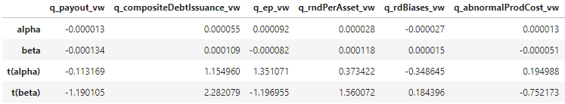

#### Table 3

Panel A, equally-weighted portfolios.

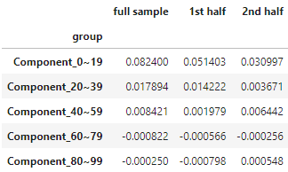

Panel A, value-weighted portfolios

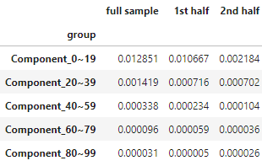

Panel B, equally-weighted portfolios.

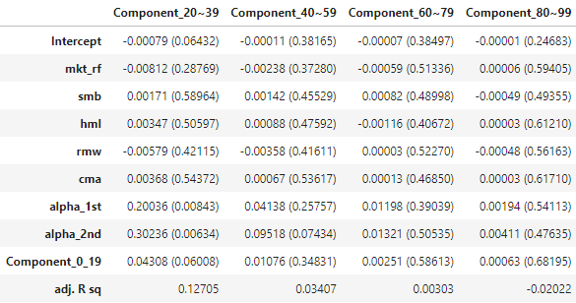

Panel B, value-weighted portfolios.

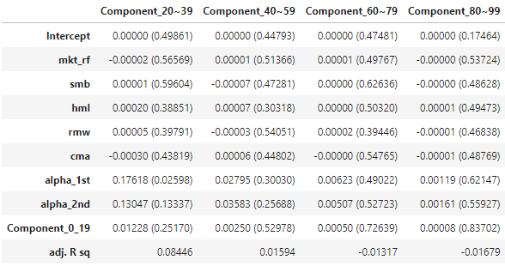

Panel C, equally-weighted portfolios

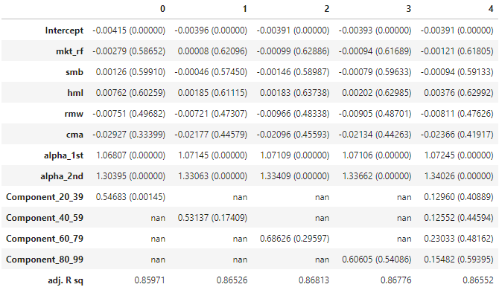

Panel C, value-weighted portfolios.

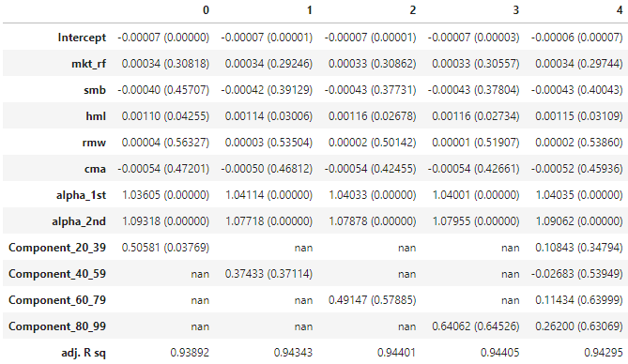

#### Sharpe Ratio

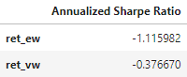

#### P&L Curve

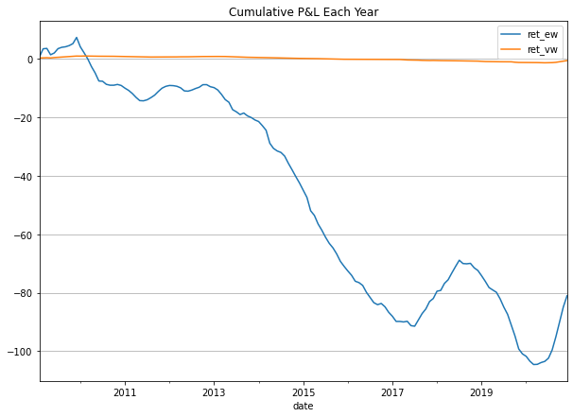

## Transaction Cost = deduct total return by 50% monthly.

We set such high rate of transaction cost to make the effect of transaction cost to P&L obvious.

### Mainland China

#### Table 1

Same as Table 1

#### Table 2

Same as Table 2

#### Table 3

Panel A, equally-weighted portfolios.

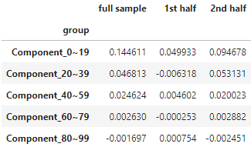

Panel A, value-weighted portfolios

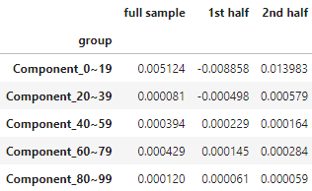

Panel B, equally-weighted portfolios.

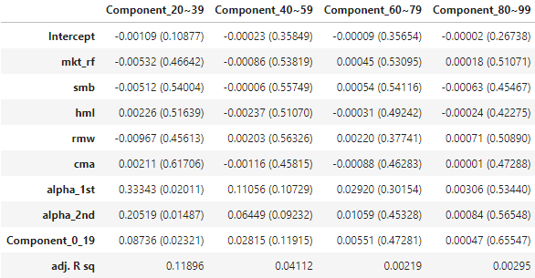

Panel B, value-weighted portfolios.

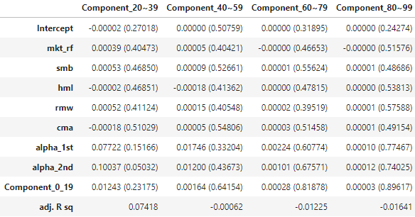

Panel C, equally-weighted portfolios

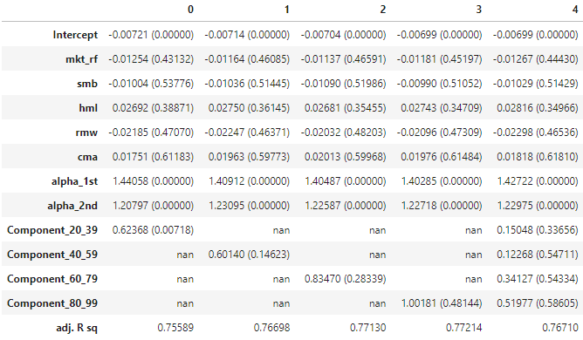

Panel C, value-weighted portfolios.

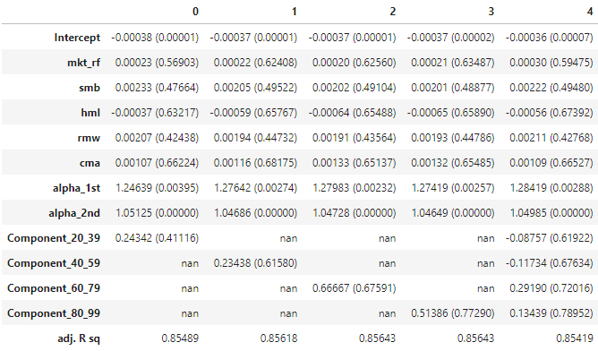

#### Sharpe Ratio

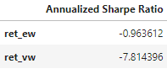

#### P&L Curve

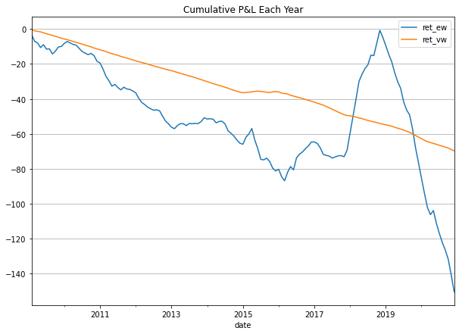

### Hong Kong

#### Table 1

Same as Table 1

#### Table 2

Same as Table 2

#### Table 3

Panel A, equally-weighted portfolios.

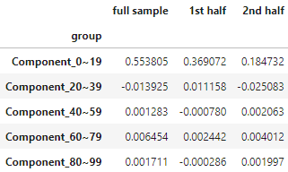

Panel A, value-weighted portfolios

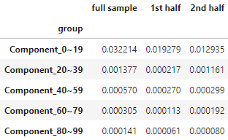

Panel B, equally-weighted portfolios.

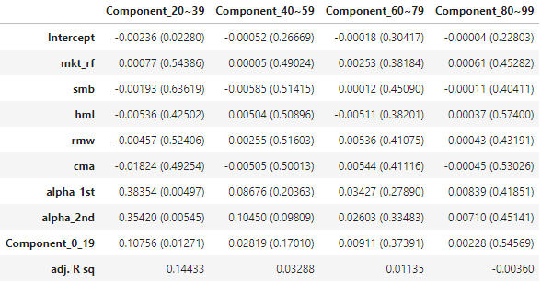

Panel B, value-weighted portfolios.

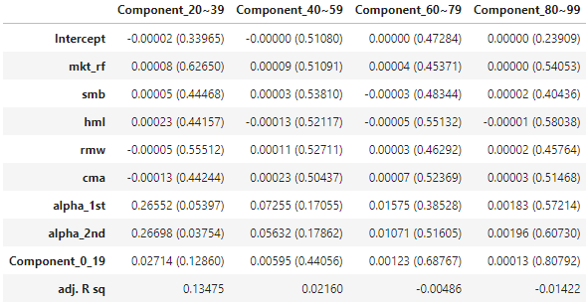

Panel C, equally-weighted portfolios

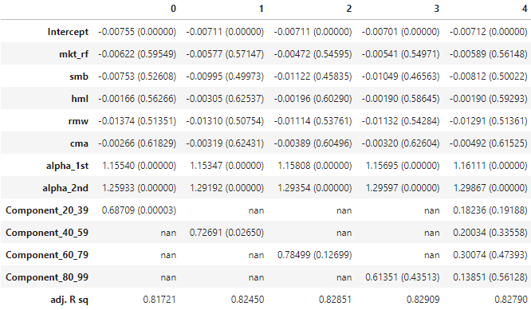

Panel C, value-weighted portfolios.

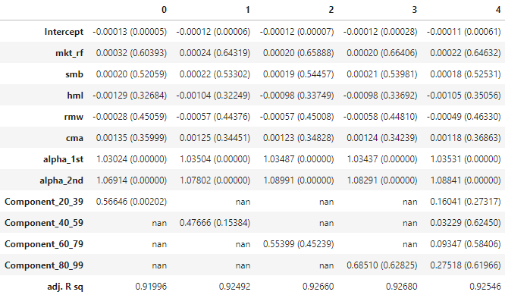

#### Sharpe Ratio

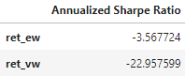

#### P&L Curve

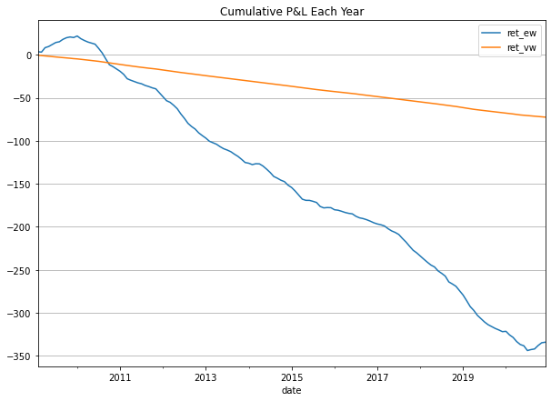

### US

#### Table 1

Same as Table 1

#### Table 2

Same as Table 2

#### Table 3

Panel A, equally-weighted portfolios.

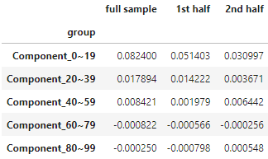

Panel A, value-weighted portfolios

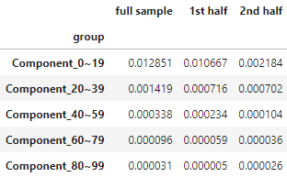

Panel B, equally-weighted portfolios.

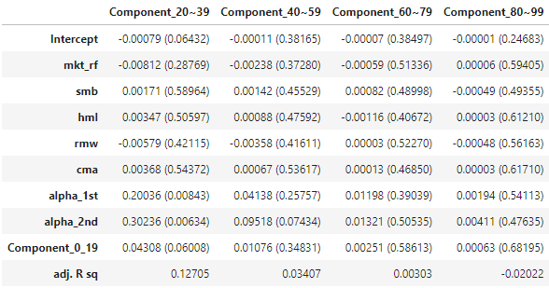

Panel B, value-weighted portfolios.

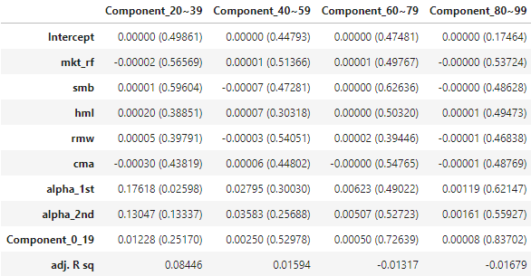

Panel C, equally-weighted portfolios

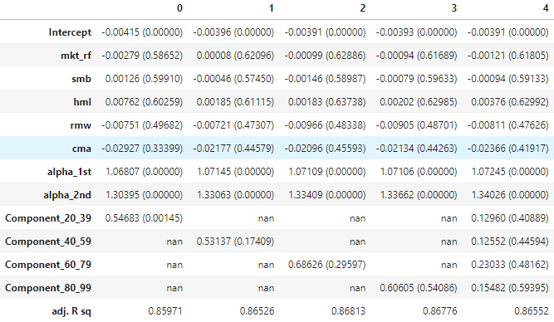

Panel C, value-weighted portfolios.

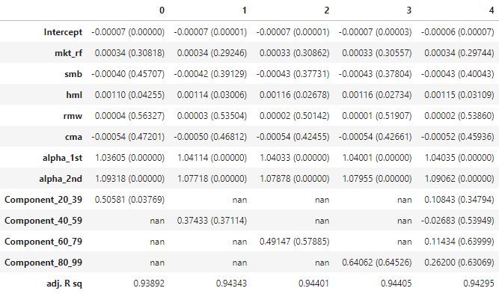

#### Sharpe Ratio

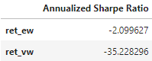

#### P&L Curve

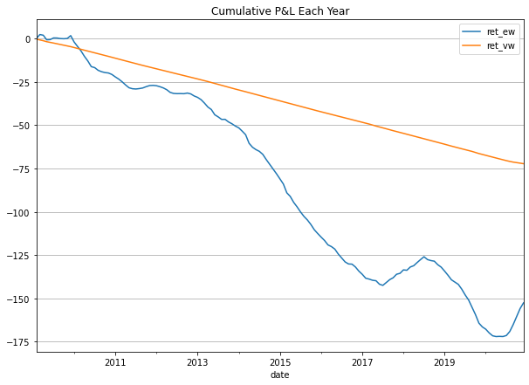

## Extra mile: Introduce 1-month moving average of factors returns, assume no transaction cost.

### Mainland China

#### Table 1

Same as Table 1

#### Table 2

Same as Table 2

#### Table 3

Panel A, equally-weighted portfolios.

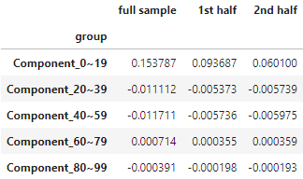

Panel A, value-weighted portfolios

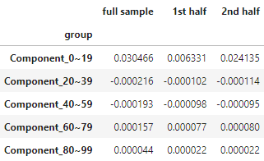

Panel B, equally-weighted portfolios.

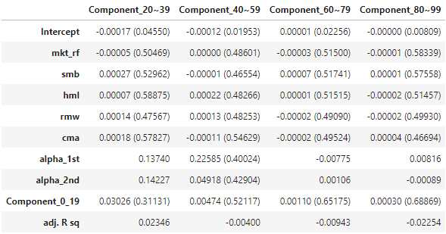

Panel B, value-weighted portfolios.

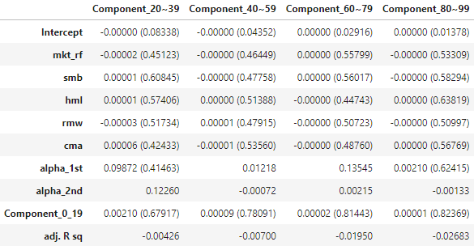

Panel C, equally-weighted portfolios

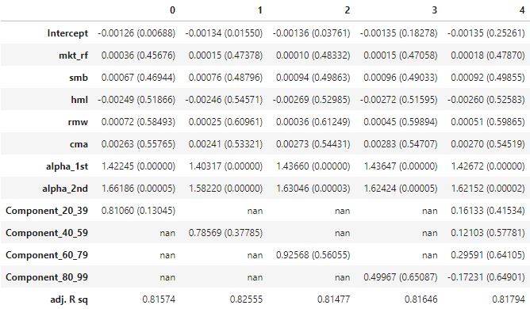

Panel C, value-weighted portfolios.

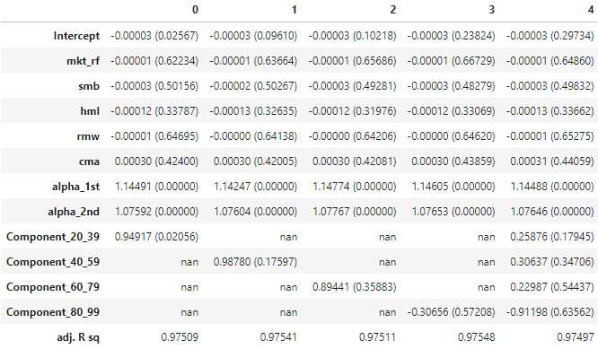

#### Sharpe Ratio

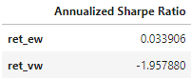

#### P&L Curve

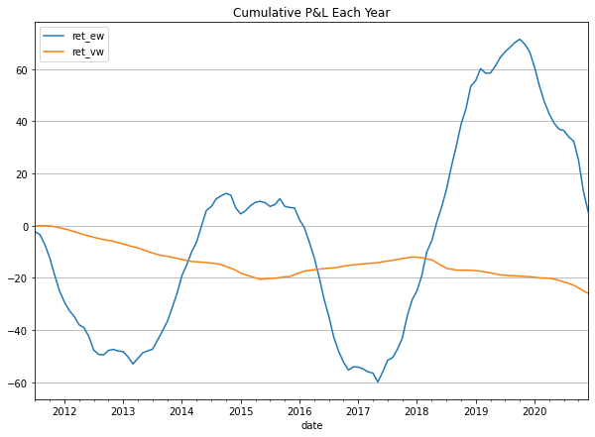

### Hong Kong

#### Table 1

Same as Table 1

#### Table 2

Same as Table 2

#### Table 3

Panel A, equally-weighted portfolios.

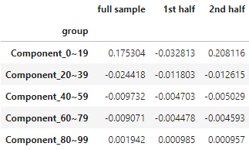

Panel A, value-weighted portfolios

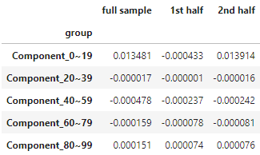

Panel B, equally-weighted portfolios.

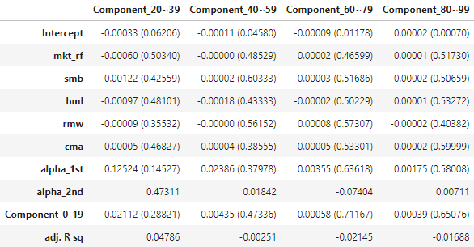

Panel B, value-weighted portfolios.

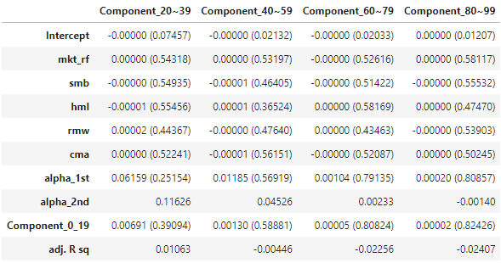

Panel C, equally-weighted portfolios

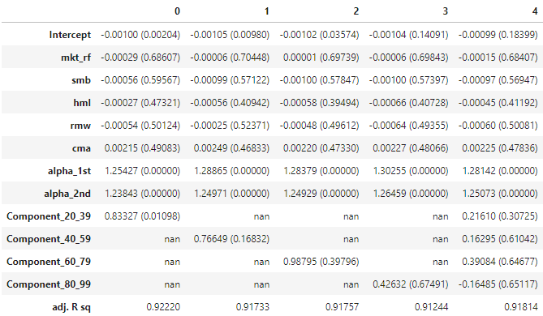

Panel C, value-weighted portfolios.

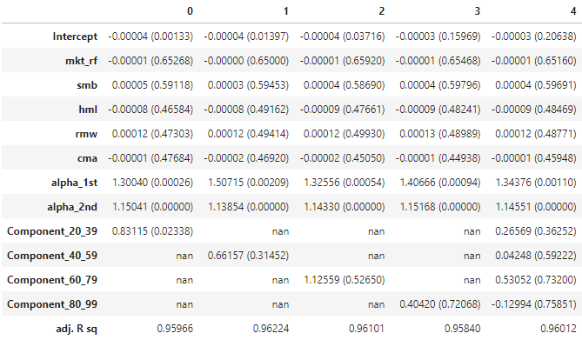

#### Sharpe Ratio

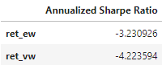

#### P&L Curve

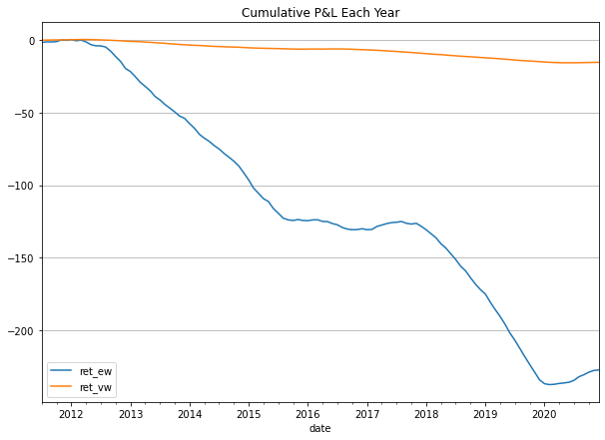

### US

#### Table 1

Same as Table 1

#### Table 2

Same as Table 2

#### Table 3

Panel A, equally-weighted portfolios.

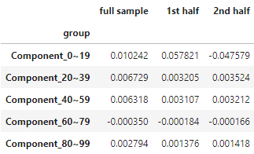

Panel A, value-weighted portfolios

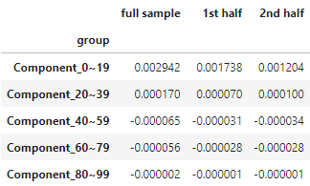

Panel B, equally-weighted portfolios.

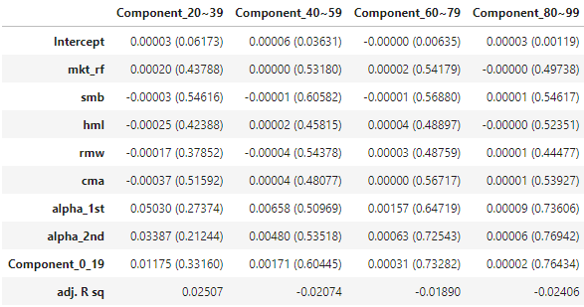

Panel B, value-weighted portfolios.

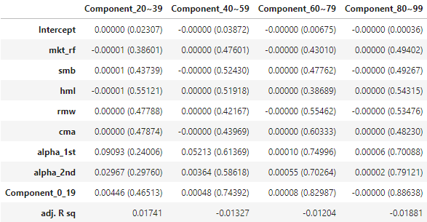

Panel C, equally-weighted portfolios

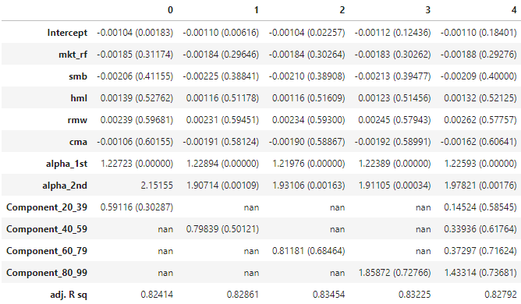

Panel C, value-weighted portfolios.

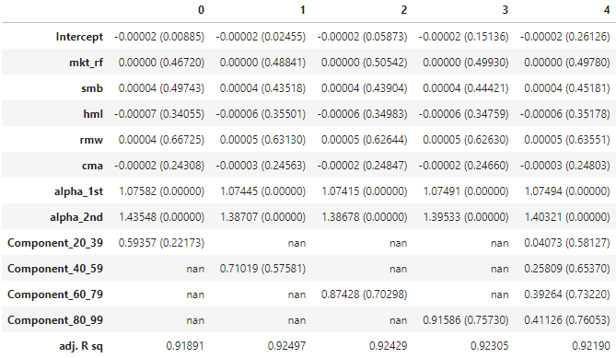

#### Sharpe Ratio

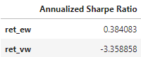

#### P&L Curve

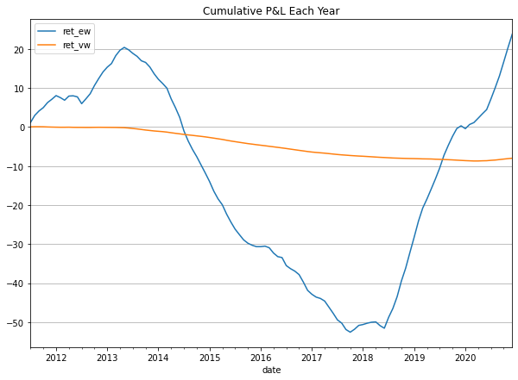

# Conclusion

## Comparison with findings in original paper.

The following compares backtest result of replication and findings of original paper. Table 1 and table 2 are not compared since data used in this replication is different from original paper.

Basic pattern of table 3, panel A of this replication matches the paper. That is, factor momentum is concentrated in high eigenvalue principal components. This makes sense as PCA always explain the most of variation in data in the first few principal components.

Authors of original paper discovered portfolios returns constructed by principal components statistically significantly correlate with one another. This agrees with result of equally-weighted portfolios but not value-weighted portfolios in section 5.1 No transaction cost and 5.2 Transaction Cost = deduct total return by 50% monthly. In table 3 panel B of equally-weighted portfolios, coefficients of variables with name “Component_X_Y” have small p-values, where X and Y are integers. However, the statistical significance is lower if X, Y become larger. This is reasonable because principal components with lower eigenvalue explain less variation of data. On the other hand, In table 3 panel B of value-weighted portfolios, the coefficients are not statistically significant. The probable reason is factor momentum is more obvious in equally-weighted portfolios than in value-weighted ones.

The authors claimed that the reverse was not true. That is, returns from principal components with low eigenvalues cannot explain principal components with high eigenvalues. This agrees with table 3 panel C in 3 scenarios: No transaction cost, Transaction Cost = deduct total return by 50% monthly. and Extra mile: Introduce 1-month moving average of factors returns, no transaction cost. Regressors with name “Component_X_Y” have high p-values.

After moving average transformation, the observation is different from original findings from Table 3, panel B. Except intercept, no regressor is statistically significant. The possible explanation is that variation of data decreases after moving average transformation. As a result, every principal component captures less signals and more noise from data.

## Comment on Sharpe Ratio of the strategy from extra mile.

Given the trading strategy is based on idea of momentum, which can be captured by moving average. In this replication, we take 1-month moving average to match trading frequency. It is hoped that introducing the technical indicator helps PCA find signal of high growth potential PC factors better.

Such transformation improves Sharpe Ratio of the equally-weighted portfolios in mainland China and US markets from negative to slightly positive and less than +1, which is not attractive. In contrast, such transformation worsens Sharpe Ratio of equally-weighted portfolios in Hong Kong market and all value-weighted portfolios.

In short, such transformation is not very helpful to improve performance of the strategy. Other transformations need to be examined to see if they can exploit the signals.

## Comment on profitability of such strategy

Equally-weighted portfolios constructed by such trading strategy is not profitable in most of the backtesting period in the 3 markets, according to section P&L of section 5.1 No transaction cost and 5.2 Transaction Cost = deduct total return by 50% monthly. In addition, returns of value-weighted portfolios are nearly 0, which shows signal of value-weighted factor momentum has been exploited. It seems prior return of factors cannot predict the future returns by using such strategy.

However, profitability slightly improves in mainland China and US markets after transforming factors data with moving average. This shows there are factors momentum to exploit in mainland China and US markets but not in Hong Kong market. However, this does not mean such strategy is always effective in mainland China and US markets. According to P&L curves in section 5.2 Transaction Cost = deduct total return by 50% monthly., they move up and down around 0% return, implying that timing is important to profit from such trading strategy.

In summary, result of this replication agrees with findings from original paper. Nevertheless, such trading strategy is not robust enough to profit in terms of time and geographical areas.

## Effect of transaction cost to the trading strategy

Transaction cost is modelled as constant charge equivalent to 50% of return per month. The cost is high so that effect to profitability of such trading strategy is obvious. In addition, such strategy trades factors, which is a collection of assets, the number of transactions so as transaction cost involved must be higher than strategies trading individual assets.

As mentioned above, such strategy is not profitable most of the time. Having additional high transaction cost worsen loss further. This shows profitability of such strategy is poor.

# Reference

Ehsani, S., & Linnainmaa, J. T. (2022). Factor Momentum and the Momentum Factor. The Journal of Finance (New York), 77(3), 1877–1919. https://doi.org/10.1111/jofi.13131